Build a Tribute Page
Objective: Build an app that is functionally similar to https://tribute-page.freecodecamp.rocks
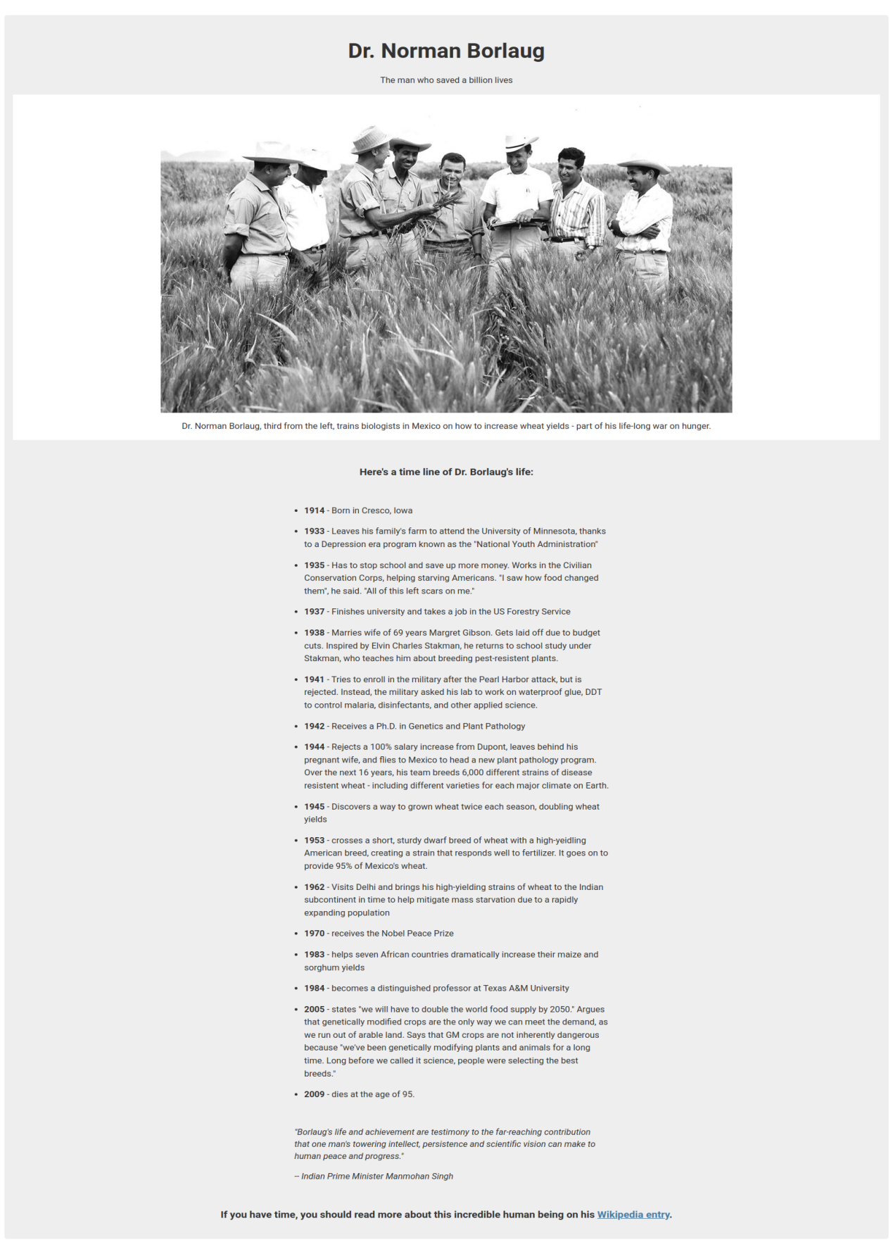

User Stories:
- Your tribute page should have a main element with a corresponding id of main, which contains all other elements
- You should see an element with an id of title, which contains a string (i.e. text), that describes the subject of the tribute page (e.g. "Dr. Norman Borlaug")
- You should see either a figure or a div element with an id of img-div
- Within the #img-div element, you should see an img element with a corresponding id="image"
- Within the #img-div element, you should see an element with a corresponding id="img-caption" that contains textual content describing the image shown in #img-div
- You should see an element with a corresponding id="tribute-info", which contains textual content describing the subject of the tribute page
- You should see an a element with a corresponding id="tribute-link", which links to an outside site, that contains additional information about the subject of the tribute page. HINT: You must give your element an attribute of target and set it to _blank in order for your link to open in a new tab
- Your #image should use max-width and height properties to resize responsively, relative to the width of its parent element, without exceeding its original size
- Your img element should be centered within its parent element
Fulfill the user stories and pass all the tests below to complete this project. Give it your own personal style. Happy Coding!
Note: Be sure to add <link rel="stylesheet" href="styles.css"> in your HTML to link your stylesheet and apply

Tests

• Waiting: You should have a main element with an id of main.
• • • Waiting: Your #img-div, #image, #img-caption, #tribute-info, and #tribute-link should all be descendants of #main.
• • • Waiting: You should have an element with an id of title.
• • • Waiting: Your #title should not be empty.
• • • Waiting: You should have a figure or div element with an id of img-div.
• • • Waiting: You should have an img element with an id of image.
• • • Waiting: Your #image should be a descendant of #img-div.
• • • Waiting: You should have a figcaption or div element with an id of img-caption.
• • • Waiting: Your #img-caption should be a descendant of #img-div.
• • • Waiting: Your #img-caption should not be empty.
• • • Waiting: You should have an element with an id of tribute-info.
• • • Waiting: Your #tribute-info should not be empty.
• • • Waiting: You should have an a element with an id of tribute-link.
• • • Waiting: Your #tribute-link should have an href attribute and value.
• • • Waiting: Your #tribute-link should have a target attribute set to _blank.
• • • Waiting: Your img element should have a display of block.
• • • Waiting: Your #image should have a max-width of 100%.
• • • Waiting: Your #image should have a height of auto.
• • Waiting: Your #image should be centered within its parent.

Dr. Norman Borlaug
The man who saved a billion lives
Dr. Norman Borlaug, third from the left, trains biologists in Mexico on how to increase wheat yields - part of his life-long war on hunger.

Here's a time line of Dr. Borlaug's life:
- 1914 - Born in Cresco, Iowa
- 1933 - Leaves his family's farm to attend the University of Minnesota, thanks to a Depression era program known as the "National Youth Administration"
- 1935 - Has to stop school and save up more money. Works in the Civilian Conservation Corps, helping starving Americans. "I saw how food changed them", he said. "All of this left scars on me."
- 1937 - Finishes university and takes a job in the US Forestry Service
- 1938 - Marries wife of 69 years Margret Gibson. Gets laid off due to budget cuts. Inspired by Elvin Charles Stakman, he returns to school study under Stakman, who teaches him about breeding pest-resistent plants.
- 1941 - Tries to enroll in the military after the Pearl Harbor attack, but is rejected. Instead, the military asked his lab to work on waterproof glue, DDT to control malaria, disinfectants, and other applied science.
- 1942 - Receives a Ph.D. in Genetics and Plant Pathology
- 1944 - Rejects a 100% salary increase from Dupont, leaves behind his pregnant wife, and flies to Mexico to head a new plant pathology program. Over the next 16 years, his team breeds 6,000 different strains of disease resistent wheat - including different varieties for each major climate on Earth.
- 1945 - Discovers a way to grown wheat twice each season, doubling wheat yields
- 1953 - crosses a short, sturdy dwarf breed of wheat with a high-yeidling American breed, creating a strain that responds well to fertilizer. It goes on to provide 95% of Mexico's wheat.
- 1962 - Visits Delhi and brings his high-yielding strains of wheat to the Indian subcontinent in time to help mitigate mass starvation due to a rapidly expanding population
- 1970 - receives the Nobel Peace Prize
- 1983 - helps seven African countries dramatically increase their maize and sorghum yields
- 1984 - becomes a distinguished professor at Texas A&M University
- 2005 - states "we will have to double the world food supply by 2050." Argues that genetically modified crops are the only way we can meet the demand, as we run out of arable land. Says that GM crops are not inherently dangerous because "we've been genetically modifying plants and animals for a long time. Long before we called it science, people were selecting the best breeds."
- 2009 - dies at the age of 95.
"Borlaug's life and achievement are testimony to the far-reaching contribution that one man's towering intellect, persistence and scientific vision can make to human peace and progress."
-- Indian Prime Minister Manmohan Singh

If you have time, you should read more about this incredible human being on his Wikipedia entry.

